USER MANUAL

**ReConciler**

**Version : 1.0.1.42517**

**Table of Contents**

1.0 SYSTEM OVERVIEW 1

**1.1** **Process Flow Diagrams** 1

2.0 SYSTEM REQUIREMENTS 2

3.0 GETTING STARTED 2

**3.1** **Main Interface** 2

**3.2** **Load Vendor Statement Data** 2

**3.3** **Complete The Automatic Matching Process** 5

**3.4** **Generate Report** 6

4.0 Appendices 9

**4.1** **Configuring The Reconciliation Template** 9

**4.2** **Setup and Installation** 11

# **1.0 SYSTEM OVERVIEW**

The program is a windows desktop that uses the.NET Framework for performance and scalability while offering a Metro UI Framework-based rich user interface and experience. The software is used to streamline the vendor reconciliation process by automatically comparing SAP postings with the real vendor statement and producing the necessary reports based on the validation outcomes.

## **Process Flow Diagrams**

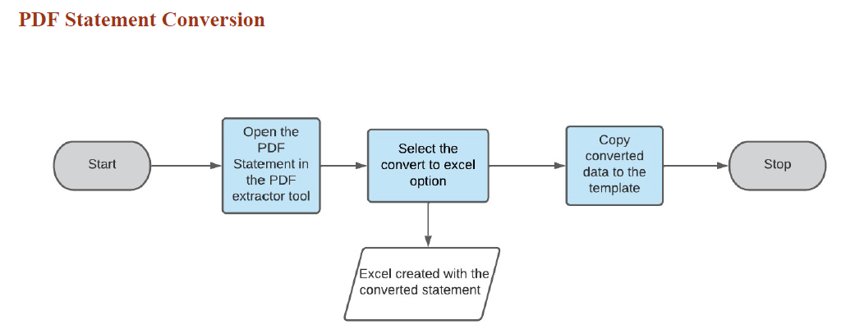

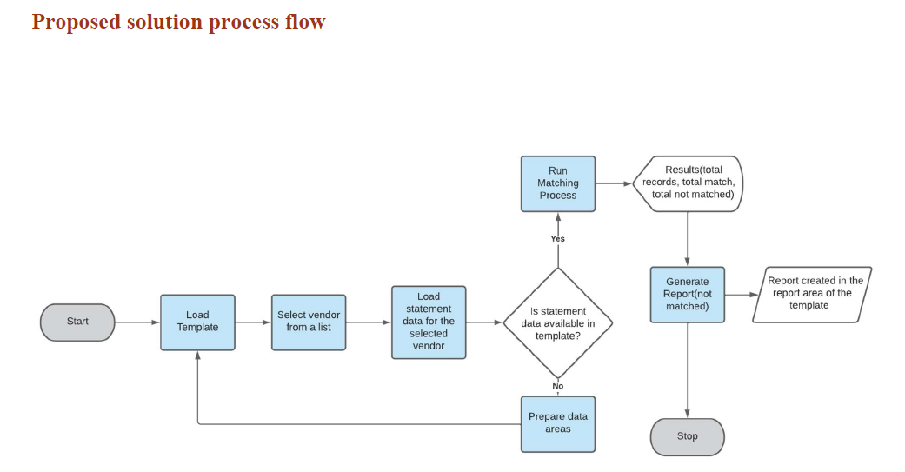

# **2.0 SYSTEM REQUIREMENTS**

The following is a list of pre-requisites to use the system:

* .NET Framework 4.7.2
* Microsoft Office Excel
* Able2Extract PDF Converter

# **3.0 GETTING STARTED**

## **3.1 Main Interface**

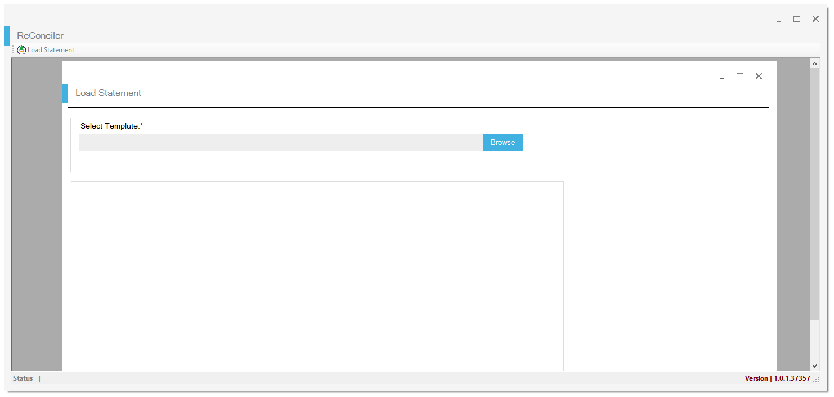

Upon launching the application, the user is presented with a main user interface with the option to browse to the template location.

## **3.2 Load Vendor Statement Data**

**Pre-requisite:**

• Vendor with PDF statement is converted into excel format.

• The statement data is available in the vendor statement data area of the template.

• The SAP Master data / lookup master is available in the lookup master area of the template.

*See Appendix 4.1 on* *configuring the reconciliation template.*

**Step 1.** Launch the desktop application using the desktop icon

The application can also be launched using the executable file which can be found in location:

**‘*C:\Program Files (x86)\Hilo Food Stores\ReConciler\ReConciler.exe’***

**Step 2.** Browse to the template location on your computer and click on the *Open* button.

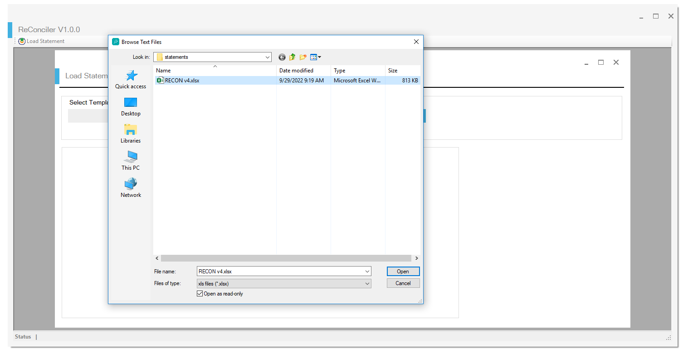

**Expected Result.** A vendor selection list will appear to the right of the *Browse* button.

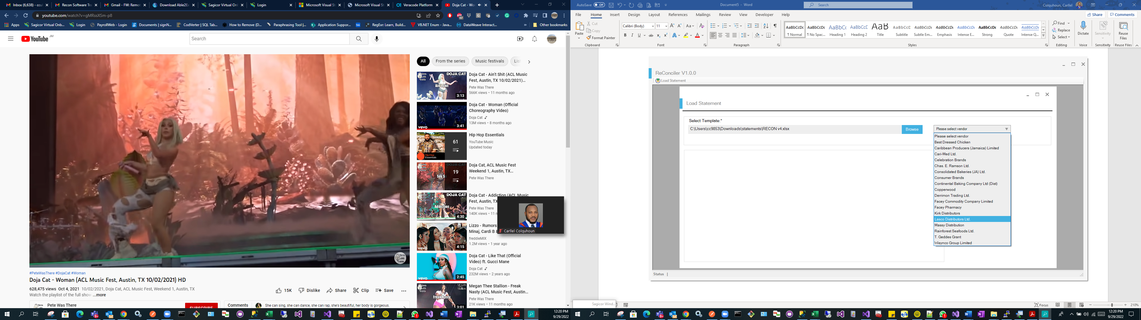

**Step 3.** Select a vendor from the vendor selection list.

**Expected Result.** The *Load Entries* button will appear to the right of the vendor selection list.

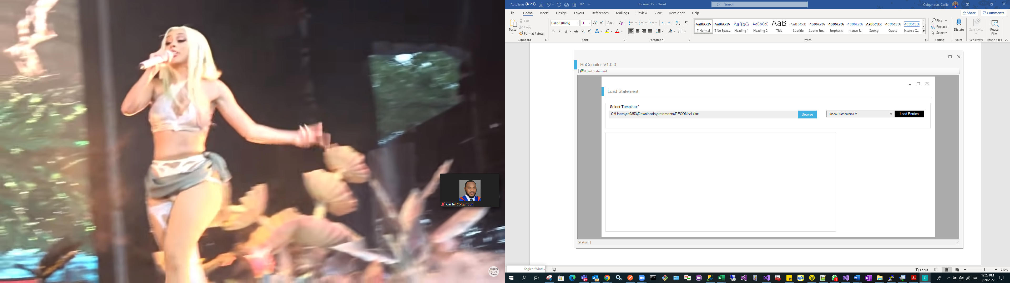

**Step 4.** Click on the *Load Entries* button to load the vendor statement from the reconciliation template.

**Expected Result.** The selected vendor's statement entries will appear in a data grid. To the right of the data grid, there will be a button labeled "Validate Entries," and three labels below it will display the total records, matched, and not matched.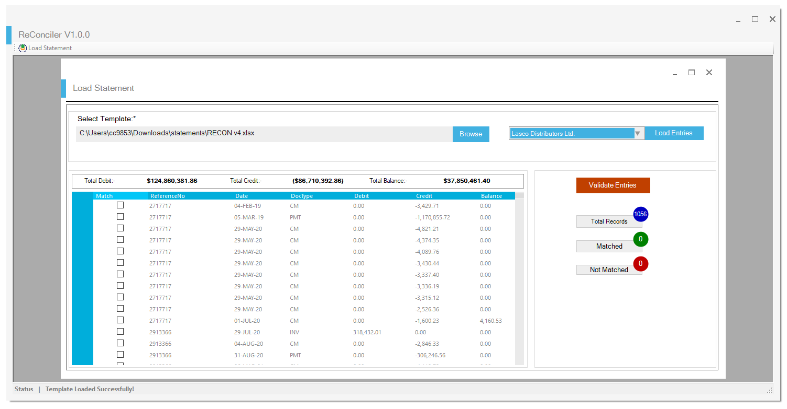

## **3.3 Complete The Automatic Matching Process**

**Step 5.** To begin the automatic matching process, click the *Validate Entries* button.

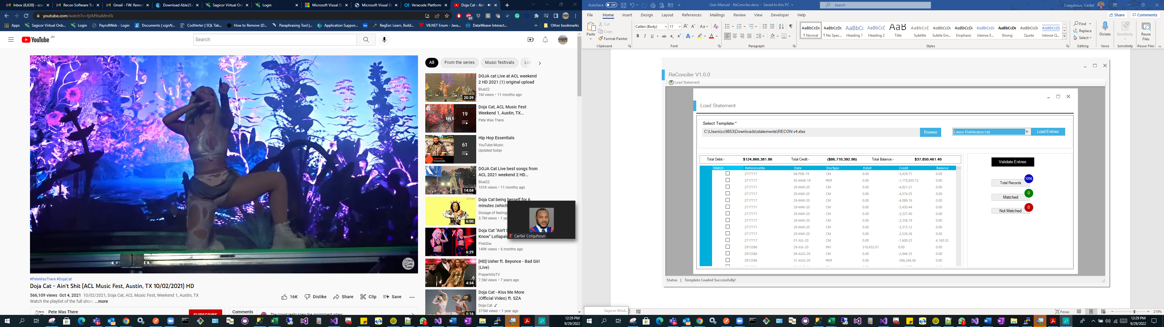

**Expected Result.** During the automatic matching, the progress bar will display the percentage of completion, and the three labels total records, matched, and not matched will be updated with the most recent count.

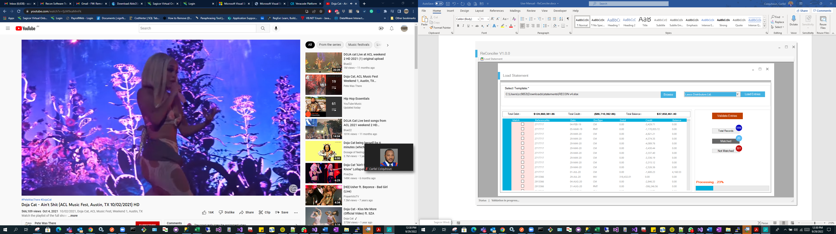

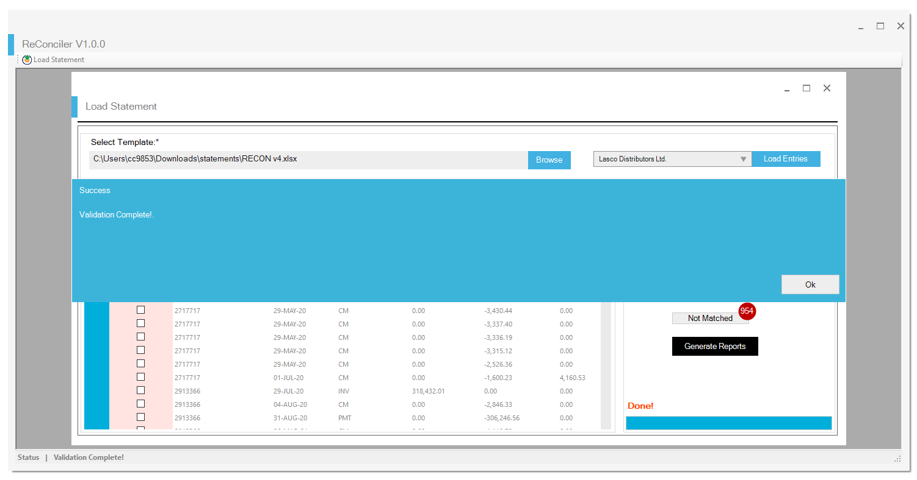

**3.4 Generate Report**

**Pre-requisite:**

• The automatic matching process (Validate entries Action) must be completed.

**Step 6.** Click on the *Generate Reports* button to create the report with the matched and not matched entries.

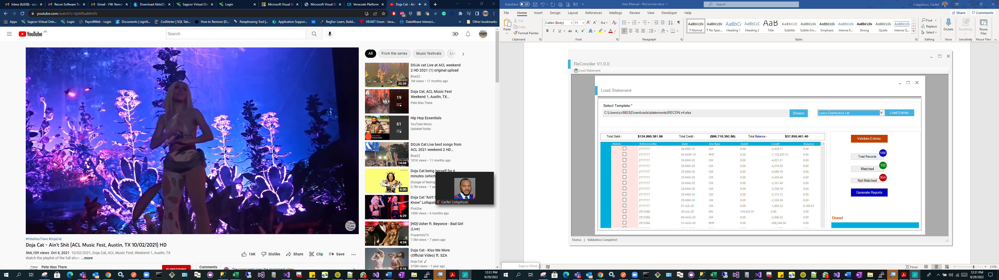

**Expected Result.** A message box will appear indicating that the report was generated successfully.

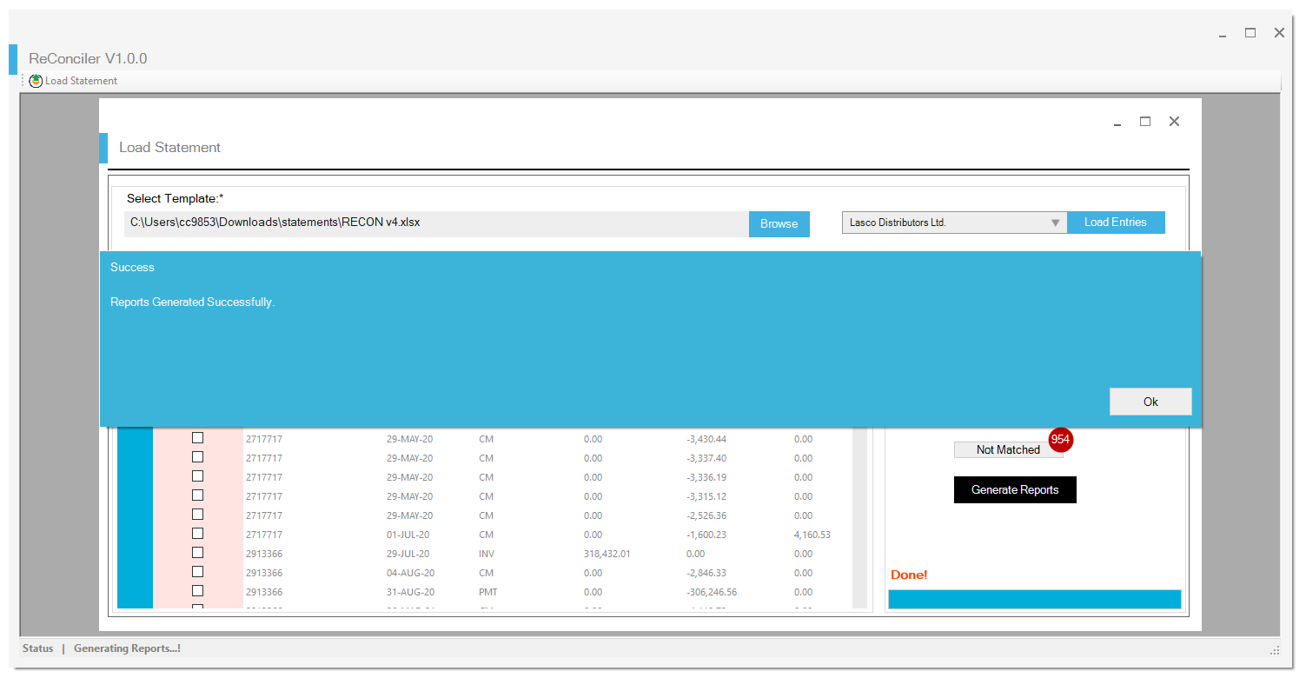

**NB: The new report will be created in the location where the reconciliation template is stored.**

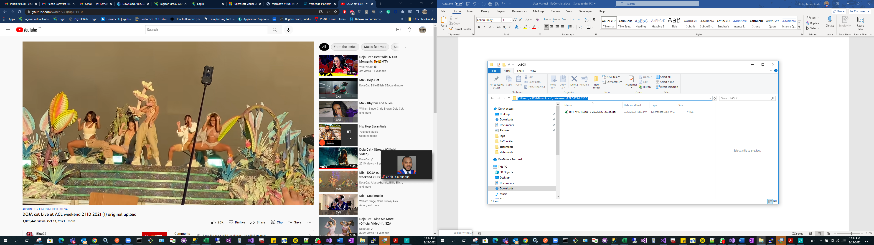

**Expected Result**. Report created with NotMatched and Matched entries.

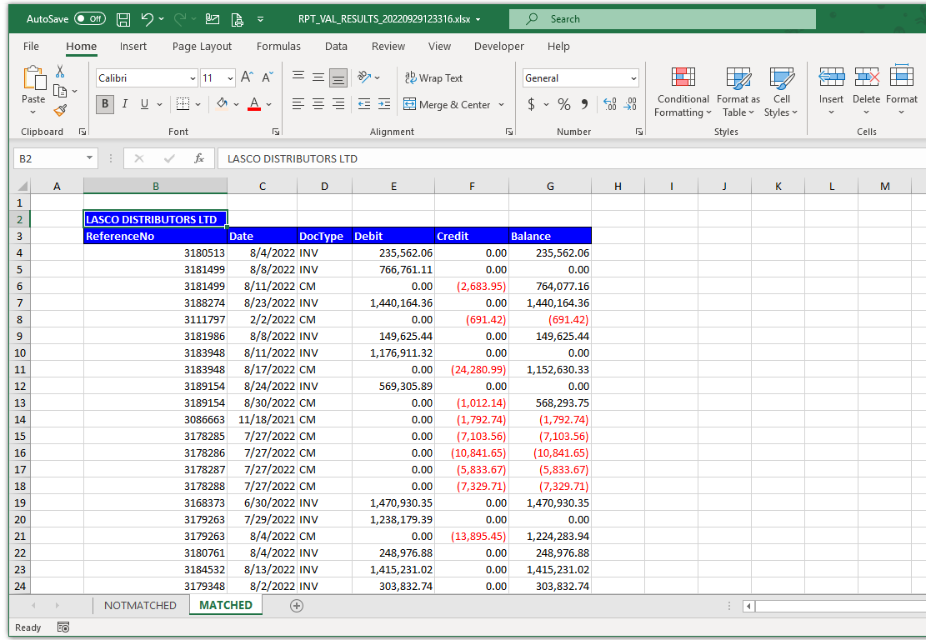

# **4.0 Appendices**

## **4.1 Configuring The Reconciliation Template**

The reconciliation template is an excel workbook that consists of two main data areas, the vendor statement and SAP master data area. These two areas must be present to proceed to section 3.2 above.

**Step 1**. Copy the extracted statement data to the vendor statement data area of the reconciliation template. This is represented by a sheet labelled with the short name for the vendor.

**Example:** “LASCO” short name for Lasco Distributors Ltd.

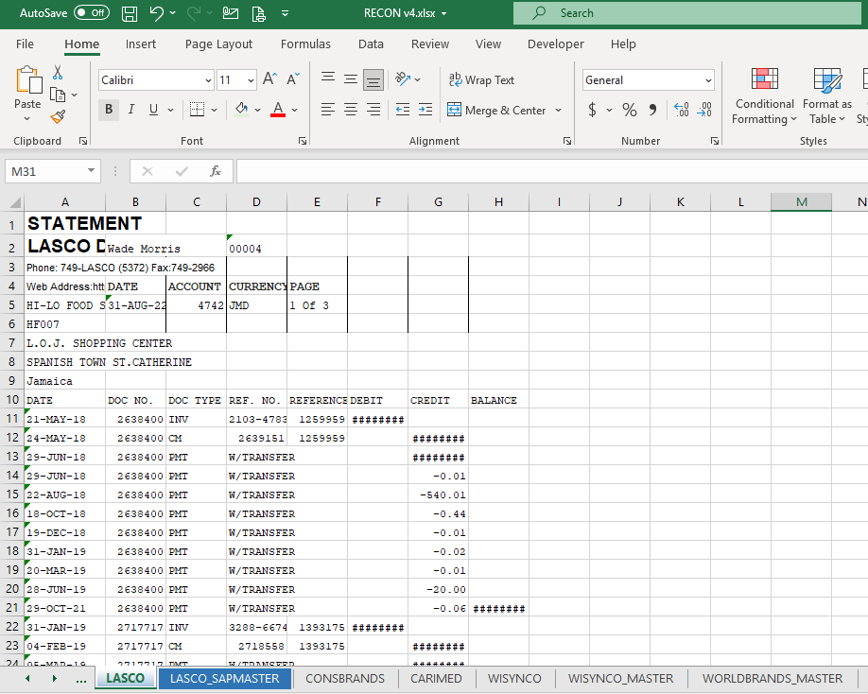

**NB: Previous statement data must be cleared before copying the new statement extract.**

**Step 2**. Copy the SAP extract to the SAP master data area of the reconciliation template. This is represented by a sheet labelled with the short name for the vendor with “SAPMASTER” appended.

Example: “LASCO_SAPMASTER” short name for Lasco Distributors Ltd.

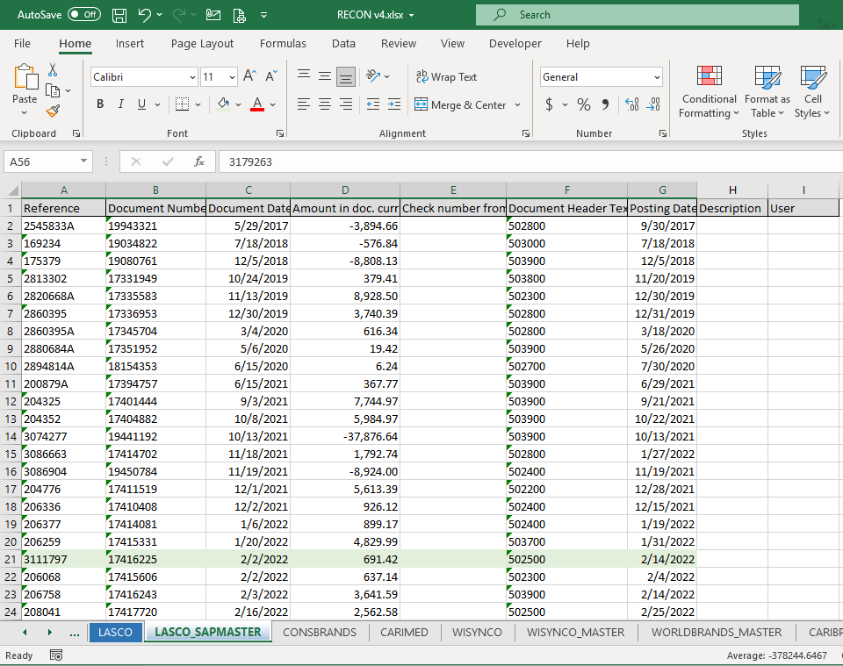

**NB: Previous SAP master data must be cleared before copying the new SAP extract.**

**Step 3**. Save the template in the desired location and ensure that it is closed.

## **4.2 Setup and Installation**

**Step 1.** Extract the *setup.zip* to the designated computer.

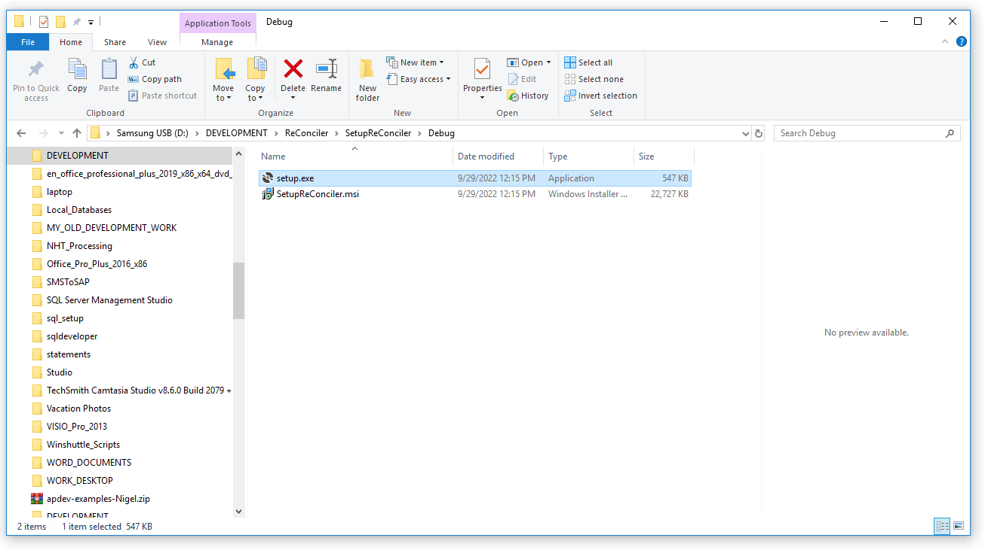

**Step 2.** Install the package by selecting the setup.exe file and run as administrator.

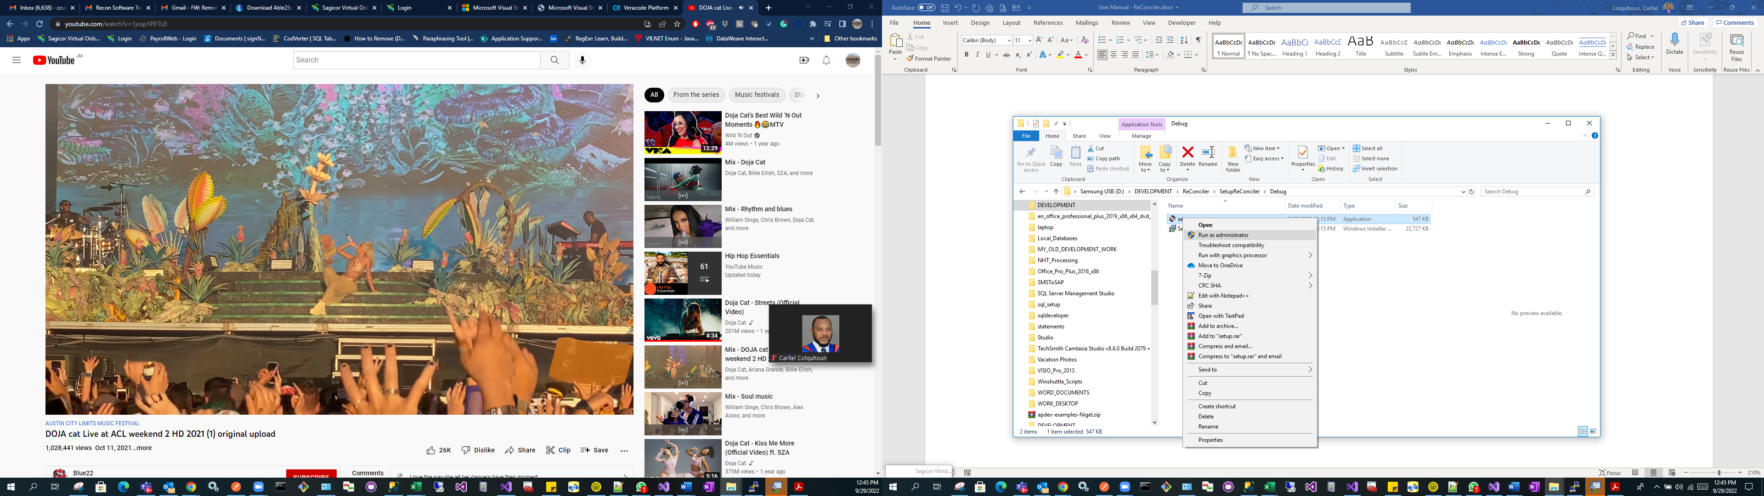

**Step 3.** Click the Next button to complete the installation wizard.

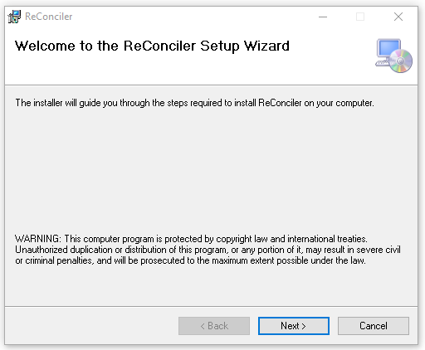

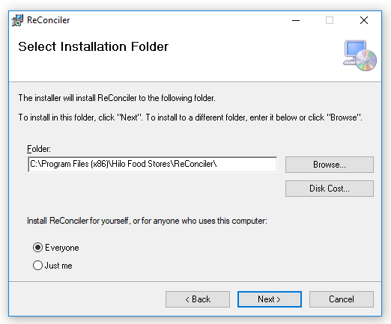

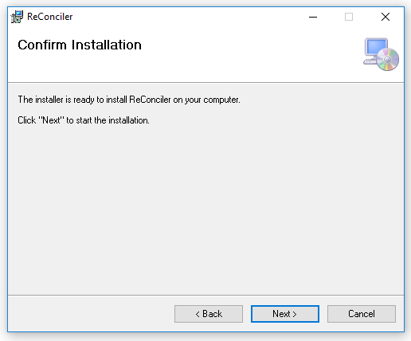

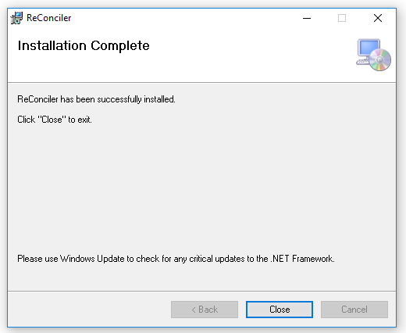

**Results.** The program will be installed in the location ***C:\Program Files (x86)\Hilo Food Stores\ReConciler***

